LABOROTORIYA ISHI №12
Mavzu: Laravel bilan CRUD amaliyoti.
Ishning maqsadi
- Laravel freymvorkining MVC (Model-View-Controller) arxitekturasini o'rganish.
- Ma'lumotlar bazasi bilan ishlash (Migrations, Eloquent ORM) ko'nikmalarini hosil qilish.
- Ma'lumotlarni qo'shish, o'qish, tahrirlash va o'chirish funksiyalarini amalda qo'llash.
Nazariy qism
Laravel — bu PHP tiliga asoslangan, ochiq kodli va simfonik (Symfony) komponentlarga tayanuvchi zamonaviy veb-freymvorkdir. Laravelning asosiy ustunligi uning MVC arxitekturasida:
- Model: Ma'lumotlar bazasi bilan bevosita ishlaydi (Eloquent ORM yordamida).
- View: Foydalanuvchiga ko'rinadigan interfeys (Blade template engine).
- Controller: Foydalanuvchi so'rovlarini qabul qilib, Model va View orasidagi mantiqiy bog'liqlikni ta'minlaydi.
CRUD amallari:
- Create (Yaratish): Ma'lumotlar bazasiga yangi yozuv qo'shish (HTTP POST so'rovi).
- Read (O'qish): Bazadagi ma'lumotlarni sahifaga chiqarish (HTTP GET so'rovi).
- Update (Tahrirlash): Mavjud ma'lumotni o'zgartirish (HTTP PUT/PATCH so'rovi).
- Delete (O'chirish): Ma'lumotni bazadan olib tashlash (HTTP DELETE so'rovi).
Artisan va Migrations: Laravelda ma'lumotlar bazasi jadvalini kod orqali yaratish uchun Migrationlardan foydalaniladi. Bu jamoaviy ishlashda bazani sinxronizatsiya qilishni osonlashtiradi.
Amaliy qism:
<!DOCTYPE html>
<html lang="uz">
<head>
<meta charset="UTF-8">
<meta name="viewport" content="width=device-width, initial-scale=1.0">
<title>Xiva: Tarixiy kitoblar katalogi</title>
<!-- Google Fonts va FontAwesome ikonkalari -->
<link href="https://fonts.googleapis.com/css2?family=Poppins:wght@300;400;600&display=swap" rel="stylesheet">
<link rel="stylesheet" href="https://cdnjs.cloudflare.com/ajax/libs/font-awesome/6.0.0/css/all.min.css">
<style>
:root {
--primary-color: #2c3e50;
--secondary-color: #d4a373; /* Xiva g'ishtlari rangi */
--accent-color: #0077b6; /* Moviy koshin rangi */
--bg-color: #f8f9fa;
--card-bg: #ffffff;
}
body {
font-family: 'Poppins', sans-serif;
background-color: var(--bg-color);
margin: 0;
padding: 20px;
color: #333;
}
.container {
max-width: 1000px;
margin: 0 auto;
}
header {
text-align: center;
padding: 40px 0;
background: linear-gradient(rgba(0,0,0,0.6), rgba(0,0,0,0.6)), url('https://images.unsplash.com/photo-1528644012110-333e6179373d?auto=format&fit=crop&w=1000&q=80');
background-size: cover;
background-position: center;
border-radius: 15px;
color: white;
margin-bottom: 30px;
box-shadow: 0 10px 20px rgba(0,0,0,0.1);
}
header h1 {
margin: 0;
font-size: 2.5rem;
text-transform: uppercase;
letter-spacing: 2px;
}
.crud-card {
background: var(--card-bg);
padding: 25px;
border-radius: 12px;
box-shadow: 0 5px 15px rgba(0,0,0,0.05);
margin-bottom: 30px;
}
.form-group {
display: flex;
gap: 15px;
flex-wrap: wrap;
}
input {
flex: 1;
padding: 12px 15px;
border: 2px solid #eee;
border-radius: 8px;
outline: none;
transition: 0.3s;
}
input:focus {
border-color: var(--secondary-color);
}
.btn-add {
background-color: var(--secondary-color);
color: white;
border: none;
padding: 12px 25px;
border-radius: 8px;
cursor: pointer;
font-weight: 600;
transition: 0.3s;
}
/* Jadval dizayni */
table {
width: 100%;
border-collapse: collapse;
background: var(--card-bg);
border-radius: 12px;
overflow: hidden;
box-shadow: 0 5px 15px rgba(0,0,0,0.05);
}
th {
background-color: var(--primary-color);
color: white;
padding: 15px;
text-align: left;
}
td {
padding: 15px;
border-bottom: 1px solid #eee;
}
.badge-id {
background: #eee;
padding: 4px 8px;
border-radius: 4px;
font-size: 0.8rem;
}
.btn-delete {
background-color: #e74c3c;
color: white;
border: none;
padding: 6px 12px;
border-radius: 5px;
cursor: pointer;
}
.btn-edit {
background-color: #3498db;
color: white;
border: none;
padding: 6px 12px;
border-radius: 5px;
cursor: pointer;
}
</style>
</head>
<body>
<div class="container">
<header>
<h1><i class="fas fa-mosque"></i> Xiva Kitoblar Katalogi</h1>
</header>
<!-- Ma'lumot qo'shish qismi -->
<div class="crud-card">
<h3><i class="fas fa-plus-circle"></i> Yangi kitob qo'shish</h3>
<div class="form-group">
<input type="text" placeholder="Kitob nomi (masalan: Ichan Qal'a sirlari)">
<input type="text" placeholder="Muallif ismi">
<button class="btn-add">Saqlash</button>
</div>
</div>
<!-- Ma'lumotlar jadvali -->
<table>
<thead>
<tr>
<th># ID</th>
<th><i class="fas fa-book"></i> Kitob Nomi</th>
<th><i class="fas fa-user-edit"></i> Muallif</th>
<th><i class="fas fa-tools"></i> Amallar</th>
</tr>
</thead>
<tbody>
<tr>
<td><span class="badge-id">1</span></td>
<td><strong>Xiva tarixi</strong></td>
<td>M. Matniyozov</td>
<td>
<button class="btn-edit"><i class="fas fa-edit"></i></button>
<button class="btn-delete"><i class="fas fa-trash-alt"></i></button>
</td>
</tr>
<tr>
<td><span class="badge-id">2</span></td>
<td><strong>Ichan Qal'a durdonalari</strong></td>
<td>S. Qurbonov</td>
<td>
<button class="btn-edit"><i class="fas fa-edit"></i></button>
<button class="btn-delete"><i class="fas fa-trash-alt"></i></button>
</td>
</tr>
</tbody>
</table>
</div>
</body>
</html>
Natijasi:
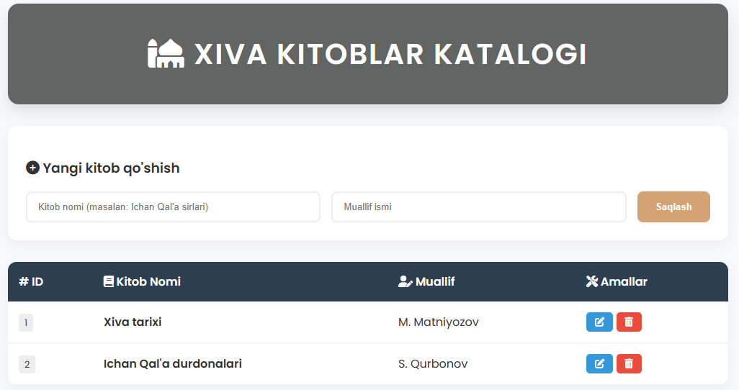
Xulosa.
Umumiy xulosa
Ushbu laboratoriya ishi davomida Laravel freymvorkida to'liq CRUD tsikli amalga oshirildi. Olingan natijalar shuni ko'rsatadiki:
Eloquent ORM yordamida SQL so'rovlarisiz ma'lumotlar bazasi bilan ishlash ancha sodda va xavfsizroq.
Blade shablonizatori HTML kodini PHP bilan juda qulay tarzda birlashtirishga yordam beradi.
Laravelning Route tizimi URL manzillarni boshqarishda yuqori darajadagi moslashuvchanlikni ta'minlaydi.
Xulosa qilib aytganda, Laravel zamonaviy veb-ilovalarni yaratish uchun eng samarali vositalardan biri bo'lib, u dasturchidan tizimli yondashuvni talab qiladi.

